**DS 501 STATISTICAL & MATHEMATICAL METHODS FOR DATA SCIENCE**

**ASSIGNMENT 5**

Name: Samama Imtiaz Butt Roll Number: 18L-1882

**PART 1: Data visualization via MDS**

Paste the scatter plot. Make sure you label the axis and make a legend to denote which color corresponds to which color.

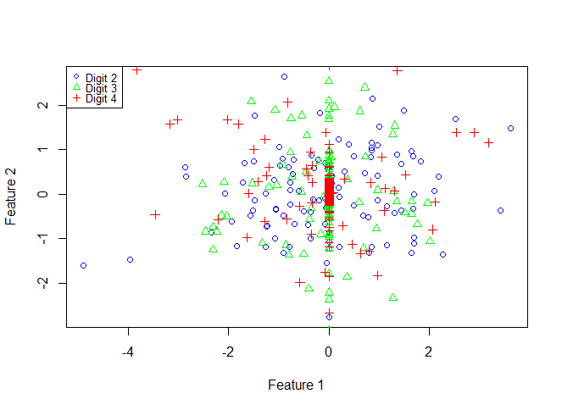

**PART 2: For digit 2:** Display only small sized 4 eigen digits corresponding to the highest eigen value. They have to fit in the following space. You do not need to print in color. Grayscale is fine.

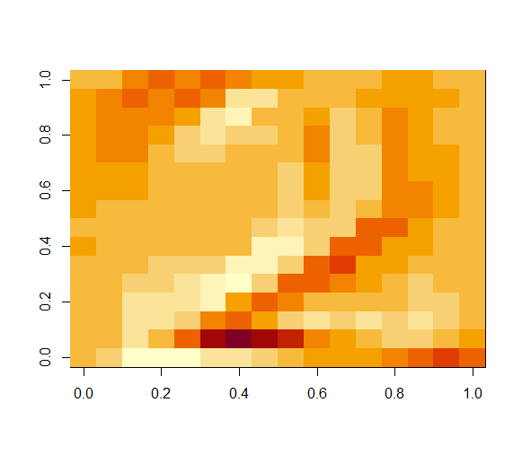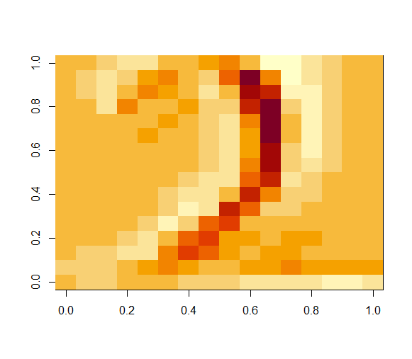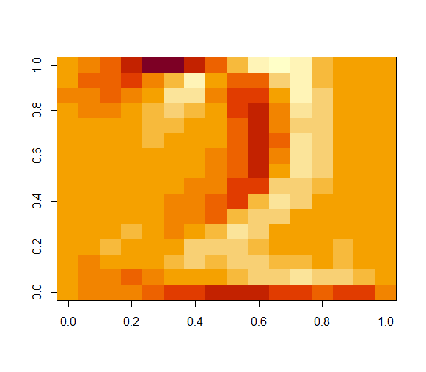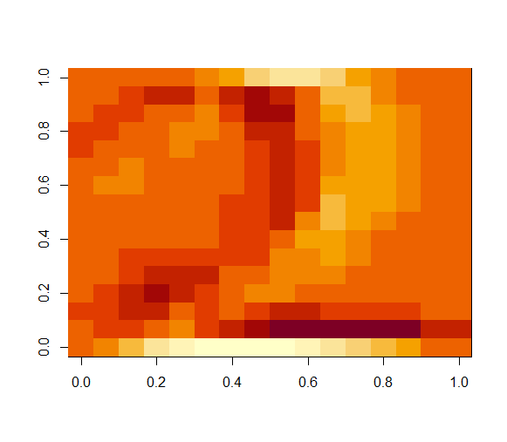

Display 4 eigen digits corresponding to the lowest eigen value. They have to fit in the following space. You do not need to print in color. Grayscale is fine.

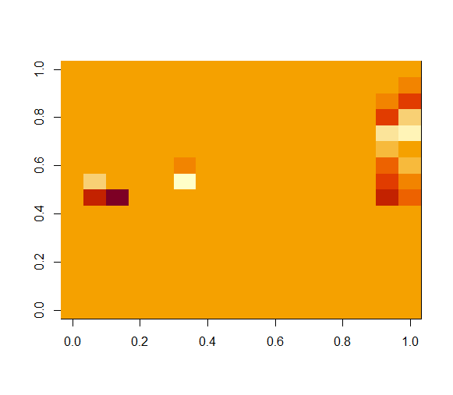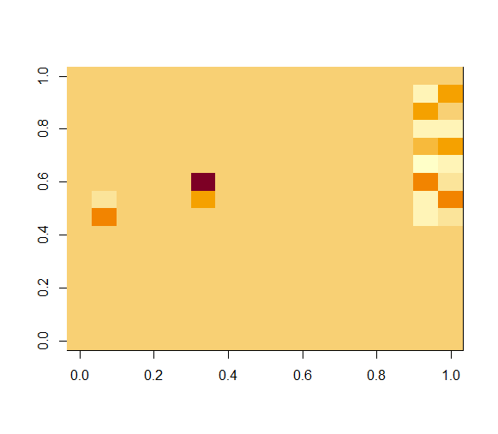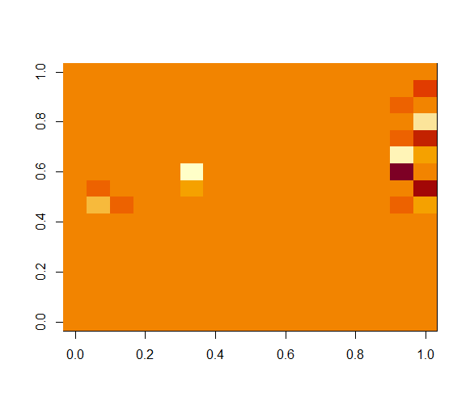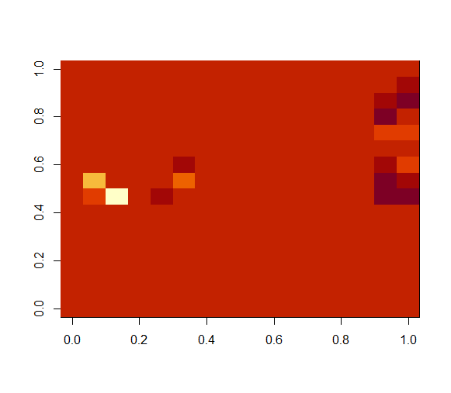

**PART 3: For digit 3:** Display only small sized 4 eigen digits corresponding to the highest eigen value. They have to fit in the following space. Grayscale is fine.

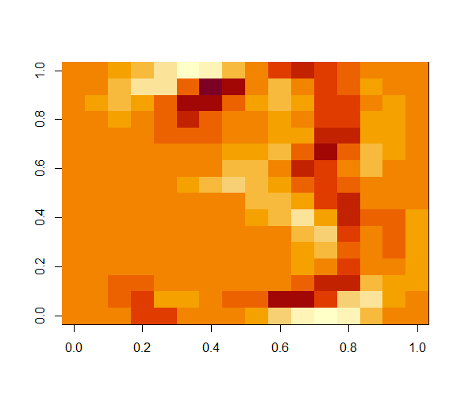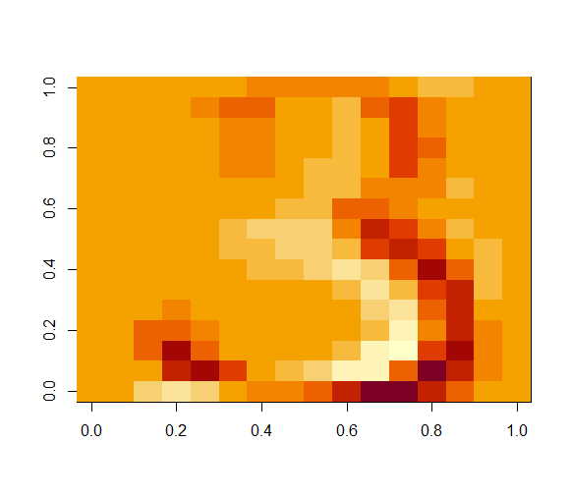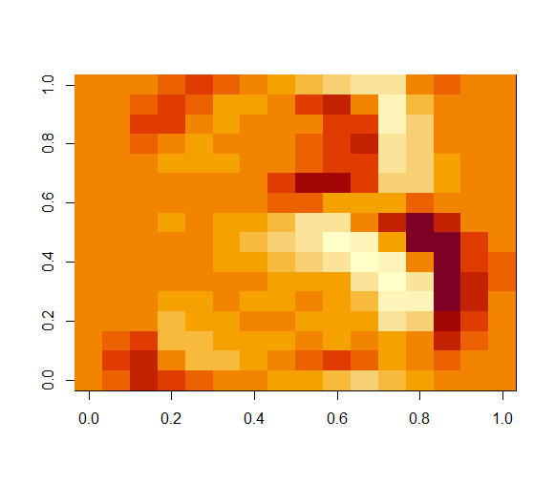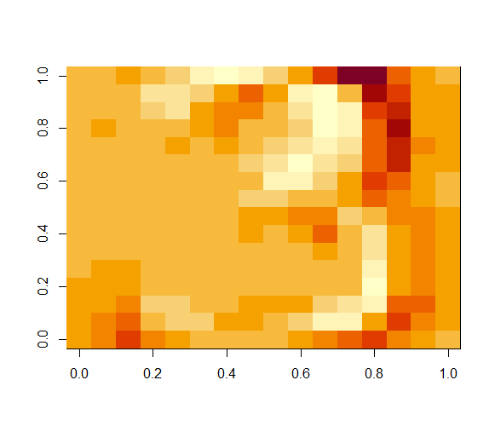

Display 4 eigen digits corresponding to the lowest eigen value.

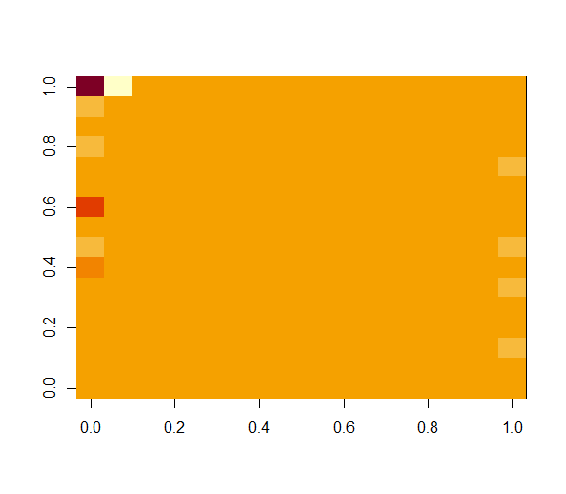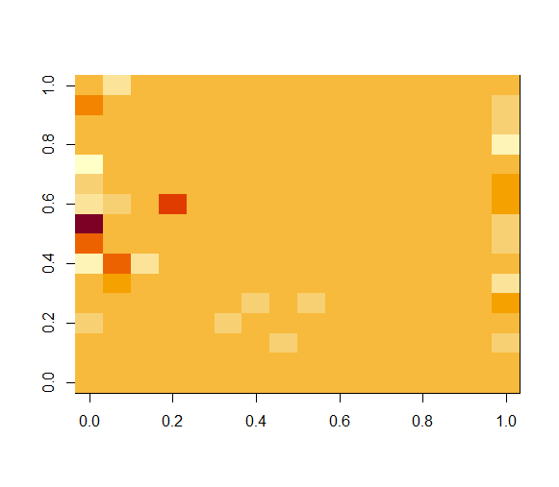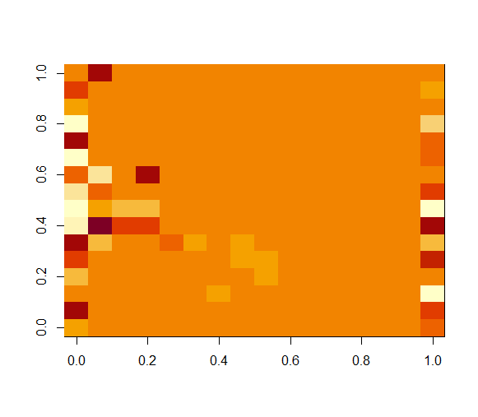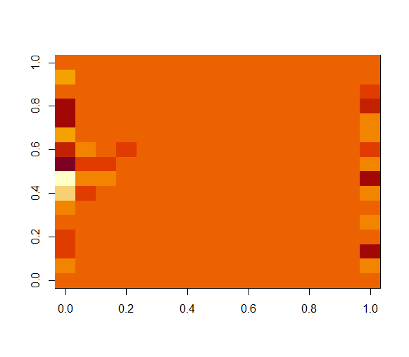

**PART 4: bonus (if done)**

|  |  |  |
| --- | --- | --- |
| **High Eigen Value** | **Low Eigen Value** | **Orignal** |
|  |  |  |

**PART 5: Your observations:** Comment on MDS in 2-4 lines. Give 2-4 lines on YOUR opinion on how you can classify different digits using Eigen digits.

MDS is used for the visual representation of the similarities and dissimilarities between a set of objects. It helps us find similarities and disimilarities of objects by displaying them on a graph with respect to their distances. It can also be used as a dimensionality reduction technique for the high dimension data.

We can classify different digits using Eigen Vectors and Eigen Values by visualizing them. We can use scatter plott to find the similarity based on the distances between objects else we can generate an image to classify them